TOWN of NEW HARTFORD
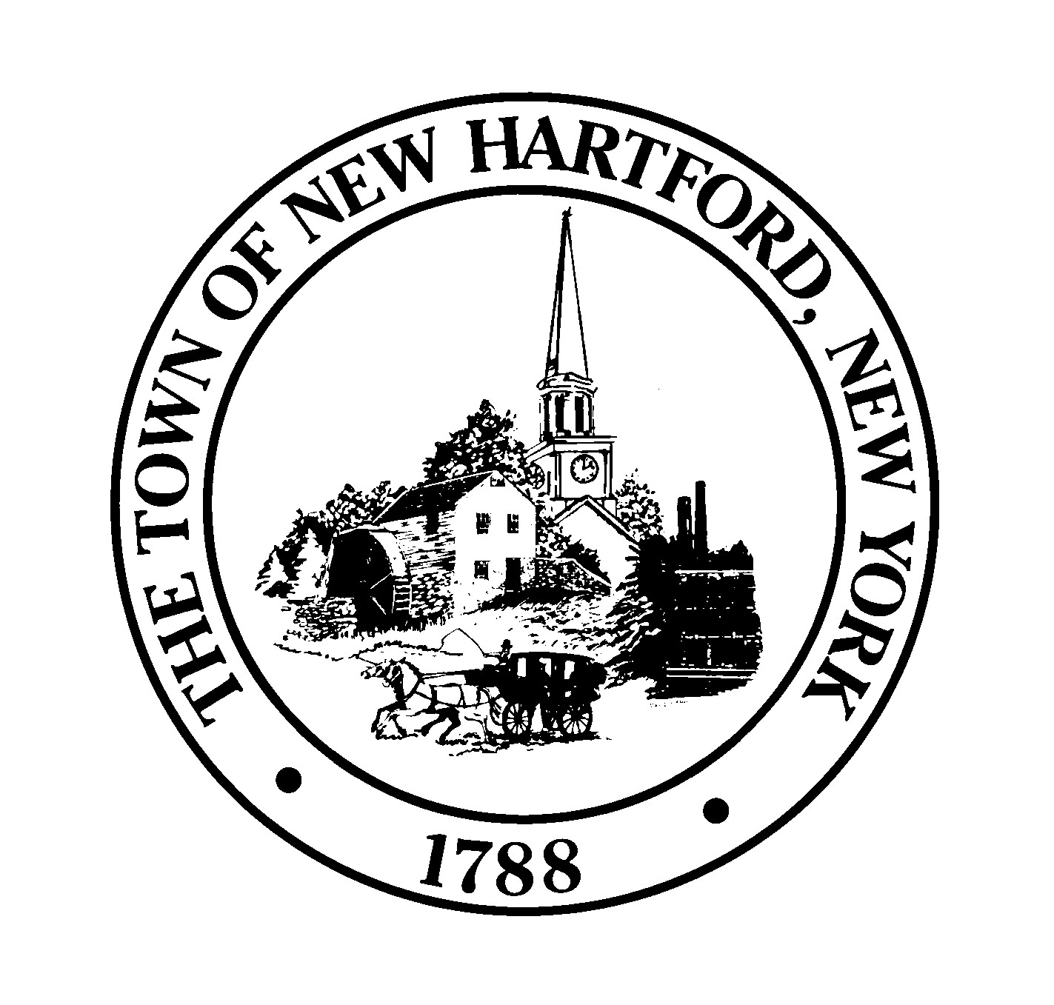
Sherrillbrook Town Park Dog Run
Phone: 315-733-7500 X2323
Fax: 315-797-9986
aalsheimer@townofnewhartfordny.gov

New Registration Form

Owner’s Last Name First Name _____________________________________
❑ Adult ❑ Senior 60+
Are you a New Hartford Resident? ❑ Yes ❑ No
Street Address _______________________________________________ City ___________ St ______ Zip __________
Home Phone Work Phone __________________ Email _______________________________
Emergency Contact & Phone

Pet Information (Vaccination Records Required)
Dog #1 Name Breed Age M/F_____Color
Dog License # Size: Small/up to 24 lbs. _____ Medium/24-50 lbs. _____ Large/over 50 lbs. _____
Rabies Vaccination Date____/____/____ ❑1yr or ❑3yr / Distemper- ❑Yes ❑No / Bordatella - ❑Yes ❑No
Dog #2 Name Breed Age M/F_____ Color
Dog License # Size: Small/ up to 24 lbs _____ Medium/24-50 lbs. _____ Large/over 50 lbs. _____
Rabies Vaccination Date____/____/____ ❑1yr or ❑3yr / Distemper- ❑Yes ❑No / Bordatella - ❑Yes ❑No
Dog #3 Name Breed Age M/F_____ Color
Dog License # Size: Small/ up to 24 lbs _____ Medium/24-50 lbs. _____ Large/over 50 lbs. _____
Rabies Vaccination Date____/____/____ ❑1yr or ❑3yr / Distemper- ❑Yes ❑No / Bordatella - ❑Yes ❑No

*All park users are required to have a Town pet tag, dog license tag, rabies ID Tag. Town pet tag will be provided with your dog park membership

NON-RESIDENTS
Single Dog | $70.00
Multi Dog | $120.00
Senior (60+) w/Single Dog | $60.00
Senior (60+) w/Multi Dog | $110.00
ANNUAL PASS – Valid through December 31st of registration year (Please check one)
NEW HARTFORD RESIDENTS
Single Dog | $35.00
Multi Dog | $60.00
Senior (60+) w/Single Dog | $30.00
Senior (60+) w/Multi Dog | $50.00

$10 Fee for replacement of lost activator - Fees half off after July 1st

For office use only

Amount Paid:_________________________ Date Purchased: ______________________ Pet Tag #: ____________________

Staff Initials: _________________________ ________________ FOB #: ______________________

PLEASE SIGN RELEASE FORM ON BACK

ACKNOWLEDGEMENT OF RISK AND RELEASE
To meet the expressed needs of New Hartford citizens, the Town of New Hartford provides a dog run at Sherrillbrook Town Park on Route 12. A dog run is an area that is fenced in and where dog owners may bring their dogs and permit them to run freely with other dogs. To make use of the dog run, owners must complete an application for dog run privileges, present vaccination records, and pay the appropriate fee. The Town requires all children who are 12 years old or younger to be supervised by an adult. The Town of New Hartford makes no guarantee that all dogs or other animals present in the dog run area are licensed or vaccinated against rabies, nor can it guarantee that children younger than 12 will not gain unsupervised admission or, that children who are admitted will behave appropriately. Further, The Town of New Hartford has no knowledge about the behavior or temperament of animals using the area.
In consideration of receiving dog run privileges for myself and the dog identified in this application, I hereby
represent and warrant as follows: my dog(s) / is/are
properly licensed in the Town of New Hartford or in , has a proper New Hartford pet I.D.#, and has received a rabies vaccination, which is fully up to date and has no history or known propensity for attacking or biting any persons or animals. I recognize that unleashing my dog and being present in an area where there are other people, including children, and other unleashed dogs pose risks to myself, and others, and to my dog and the dogs and property of others. For instance, there is the risk of personal injury or property damage to myself, or others from aggressive dogs, the unpredictable behavior of dogs, and the lack of adequate training of my dog or other dogs. I further understand and accept that despite the efforts of the Town of New Hartford to see that dog run users comply with licensing and vaccination requirements there is a risk that not all dogs present in the dog run are licensed and vaccinated. Additional risks to myself and others include, but are not limited to, dog fights, dog bites, dog theft or unlawful capture, dog escape over and under fences, and dog access to vegetation or standing water that may be unhealthy or poisonous if consumed. Further, dogs may be exposed to burrs or seeds that may become lodged in the dogs coat, feet, eyes, nose or ears, and mosquitoes, ticks, chiggers, fleas or other insects and wildlife that might be found in a park such as snakes raccoons, opossums, etc. I understand that use of the dog run is self-directed and not supervised by any agent or employee of the Town of New Hartford. I assume all risks associated with using the dog run, including its fixtures and equipment, in an unsupervised and self-directed manner.
I HEREBY RELEASE THE TOWN OF NEW HARTFORD, ITS OFFICERS, EMPLOYEES AND AGENTS FROM ANY AND ALL RESPONSIILITY OR LIABILITY FOR INJURIES OR DAMAGES TO MYSELF OR MY DOG DUE TO MY USE OF, OR PARTICIPATION IN ACTIVITIES AT, DOG RUN. I ALSO AGREE TO INDEMNIFY AND SAVE HARMLESS THE TOWN OF NEW HARTFORD ITS OFFICERS, EMPLOYEES AND AGENTS FROM AND AGAINST ALL LOSS, COST, DAMAGES, EXPENSE AND LIABILITY INCLUDING DEATH, PERSONAL INJURY OR DISEASE AND DAMAGE TO REAL OR PERSONAL PROPERTY RESULTING FROM (1) MY NEGLIGENT ACTS; (2) THE ACT OR BEHAVIOR OF MY DOG, AND (3) INJURY THAT MAY OCCUR TO ME OR MY DOG OR MY PROPERTY AS A RESULT OF THE ACTS, CONDUCT OR BEHAVIOR OF OTHER USERS OF THE FACILITY, INCLUDING OTHER DOGS.

By submitting this application and attached dog license, I represent and warrant that the records are the true and accurate records for the dog identified in this application, and that the information provided is accurate and truthful. I realize that providing false information or breaching any of the conditions or rules of use may result in revocation of dog run privileges.
I have carefully read the Assumption of Risk and Release and understand and accept its terms and conditions. I have also received a copy of the rules for dog run usage and agree to abide by these rules. I realize noncompliance of dog run rules may result in revocation of dog run use privileges and any other penalties provided by law.
Owner Name (Print) Owner Signature Date

